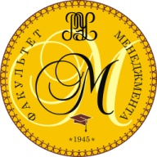
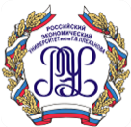

PLEKHANOV RUSSIAN UNIVERSITY OF ECONOMICS
SCHOOL OF MANAGEMENT

Dear colleagues and students,

You are kindly invited to participate in our International Business Week “Strategic Management in Global Economy” that is to be held from 13th January, 2020 to 17th January 2020.

International Business Week venue: Plekhanov Russian University of Economics
36, Stremyanny Pereulok, Moscow, Russia

Students will set up a business project for international companies located in Russia.
To solve the case it is necessary to have skills in economics and management, the ability to think out of the box, work in a group, speak fluent English and be creative. Except solving the Business case, students will have an excursion around Moscow and company visits.

Upon completion of the project, participants will be awarded with the certificates.
The participation fee is € 235 and it includes:
- 4 nights in the students’ dormitory (double or triple accommodation);
- 5 breakfasts, 5 lunches, 3 coffee breaks, one dinner;
- 1 excursion (Moscow sightseeing tour);
- Company visit;
- Certificate of participation.

Business Week language: English
The invited participants: Bachelor or Master students
We hope to see you and your students in Moscow!

Organizing committee:
School of Management
117997, Moscow, Stremyanny Pereulok, 36
Campus 2, room 334.
The secretary of the Organizing Committee: Ekaterina Demidova
Ekaterina Zueva
katerinazuevaa@gmail.com
+7 901 703 01 96
With kind regards,
Maxim A. Ponomarev
PhD (Economics), Associate Professor,
Dean of the School of Management

